**Team J-Hawk Deployment Plan**

So we have just finished Working our APP “What to play?” ,and we want to deploy the app on Google play store. First we have to meet the google’s app standards before we can put an app on the play store.

Requirements

1. In order to publish an app you have to become a develop with Google play store ,this will require a one time fee of $25. Visit https://play.google.com/apps/publish/signup/ follow the steps, Pay the $25, become a publisher.
2. Google Requires that every app has a cryptographic key that expires after October 22, 2033. Cryptographic keys are used as a certification to insure that the app is authentic by confirming the publisher, and it ensures that publisher is using an authentic version in the play store. Cryptographic keys ensure that you are the sore publisher of the app.
3. Google play store also has a size require to almost 100MB. If you app happen to be big that you will have to use APK EXPansion Files. This no cost cost to the developer.

## **Preparing Promotional Assets**

Google also requires the publisher to has some promotional screenshot/video and description. In the play store when you go to the install page in the play store there are screenshots of the application an

description explaining what the app does. The screenshot are required 24 bit PNG or JPG with no alpha channel

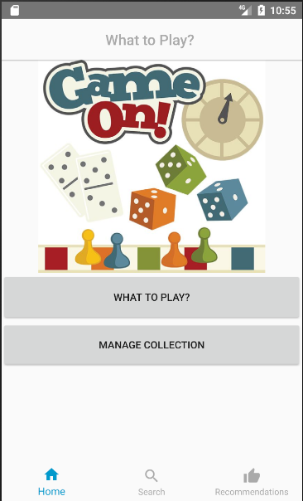

Here We you present Our Home Page, This will give the customer an idea of what to expect.

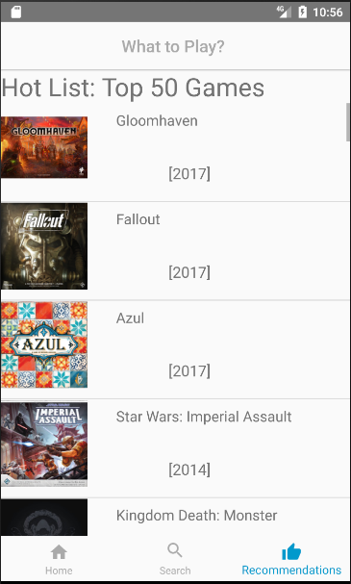

The Next Picture show the customer that we have Our Daily recommended Games items that are available. The

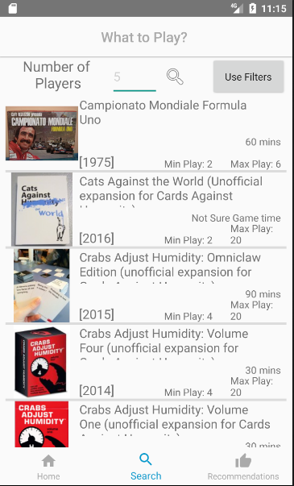Here We you present Our search page, This will give the customer an idea of what to expect, in the app.

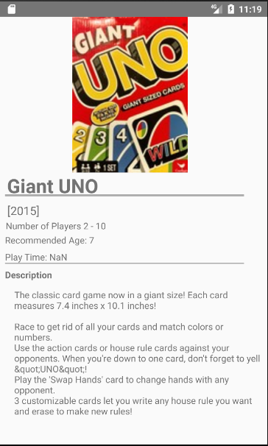The Next Picture shows the customer that the app has a clear page to view details about a games.

### **Launcher Icons**



Google play requires that the launcher icons be ldpi (120dpi) – 36 x 36 px

mdpi (160dpi) – 48 x 48 px, hdpi (240dpi) – 72 x 72 px, xhdpi (320dpi) – 96 x 96 px.

A launcher icon is what is used to represent the application, each icon should be a 32 bit png. Google suggest that the application be simple and clean are memorable and are easier to distinguish.

## **Publishing to Google Play**

Once we compile the APK and the prepared the promotional assets. We will use the program Xamin. This is what you see when you open it and you just click “publish Android Apps on Google Play Store”. Make sure you sign in with a developer/publisher email.

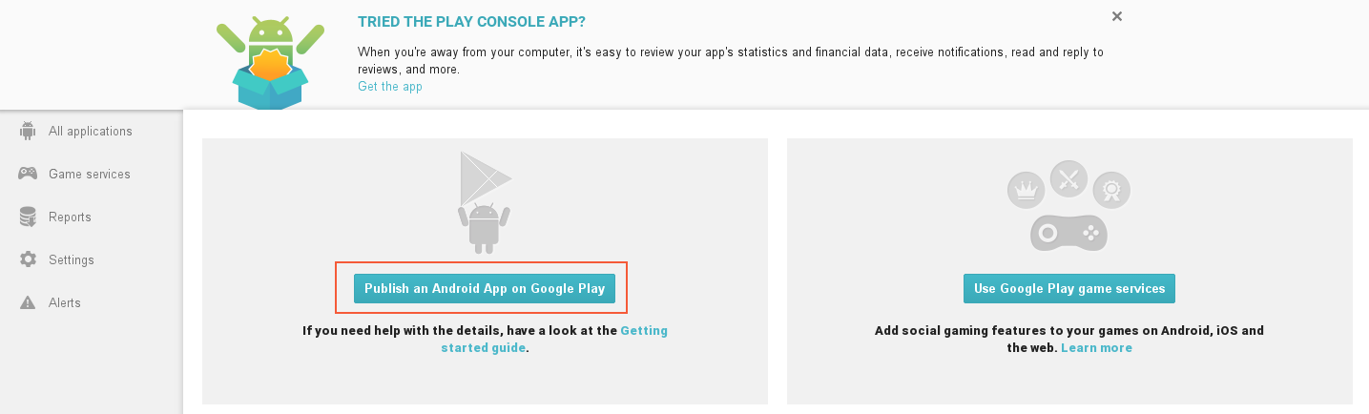

Then you want to hit New Application

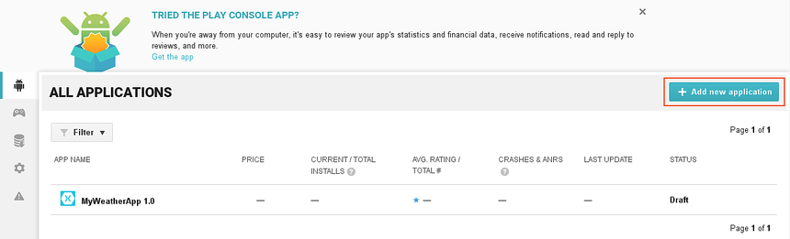

The New Application window pops up that’s when we would add the app Name “What to Play?”

We already have the APK file, which is what android apps and formatted as the we ould upload the file.

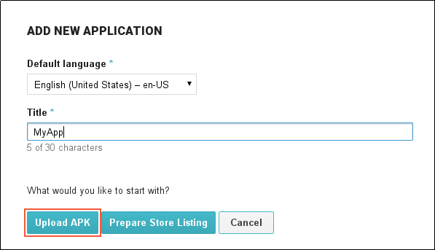

Click up upload

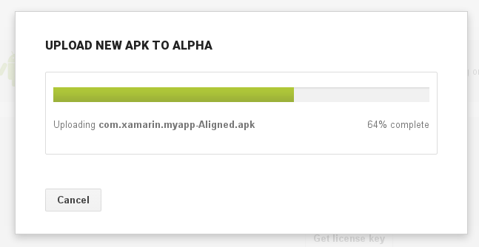

After the APK is done being uploaded, it is kept as a draft. We ca’t can’’t the app yet until the app google has more details about the app.

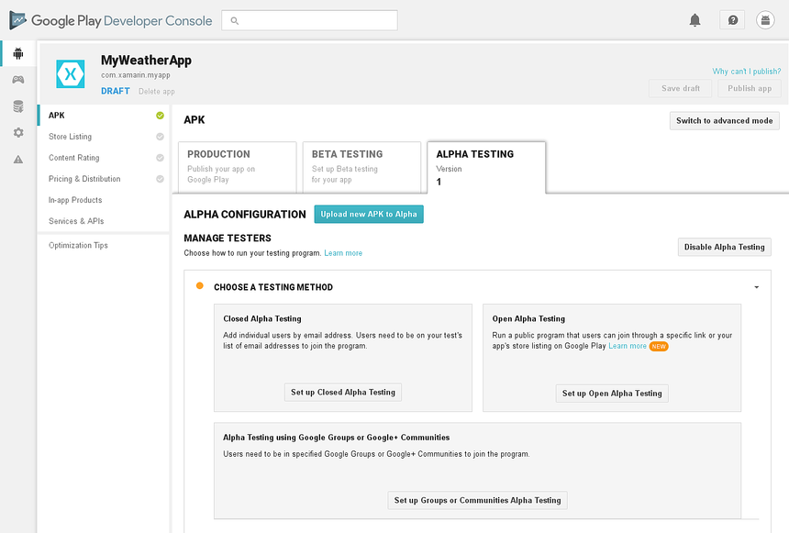

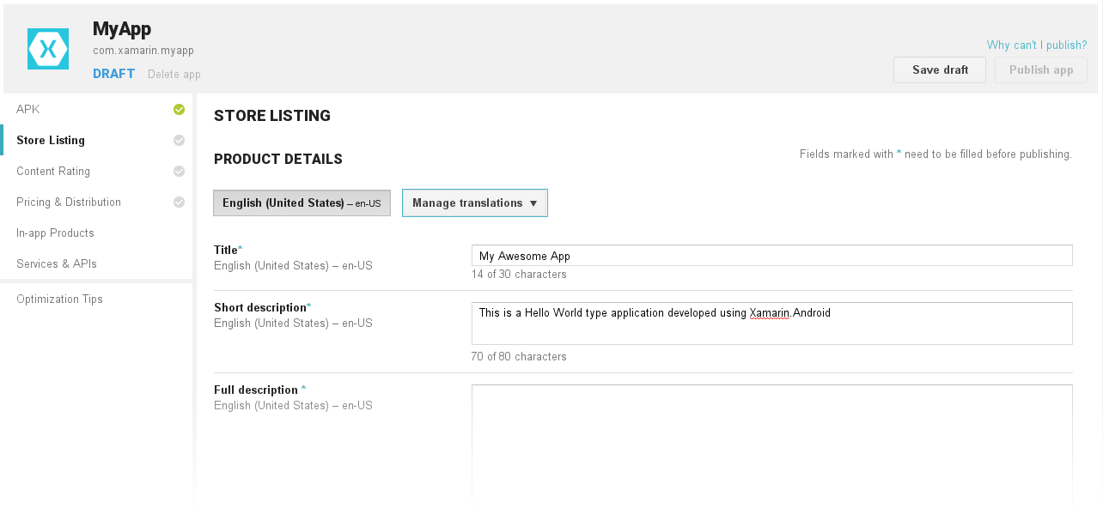

We click store listing the we would fill in the field showed above

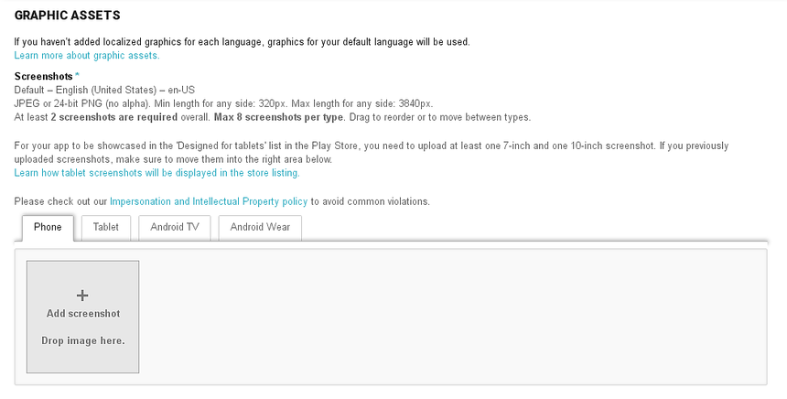

This is where we would upload all the screenshot that we before, for publication.

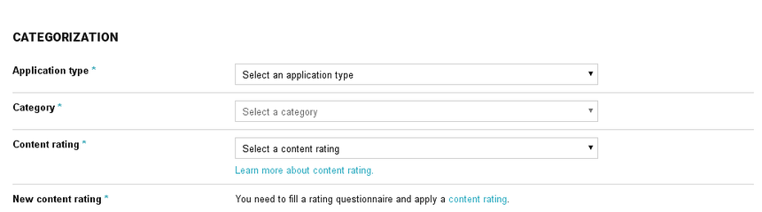

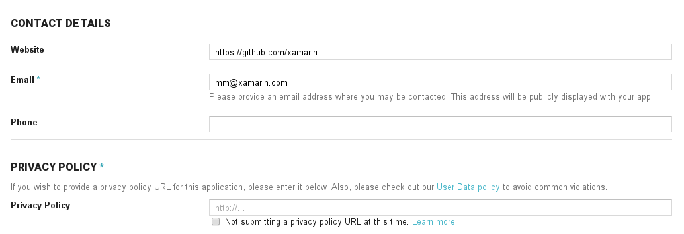

We would fill the probably put the app in the Game caregore and set the rate at E for everybody, then provide out contact information.

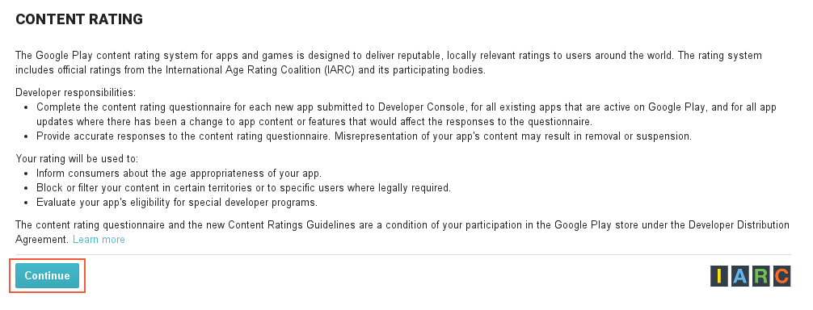

Then agree to Google’s rating policy.

**Rating E Everyone** – May not access, publish, or share location data. May not host any user-generated content. May not enable communication between users.

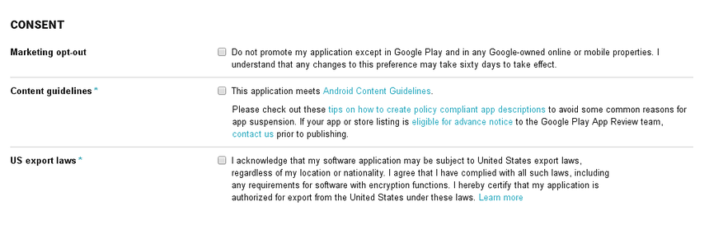

Give consent for Marketing opt-out and content guide line also us export laws.

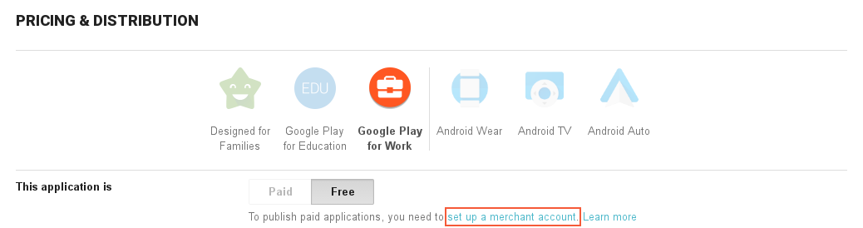

Download json and to have Client id

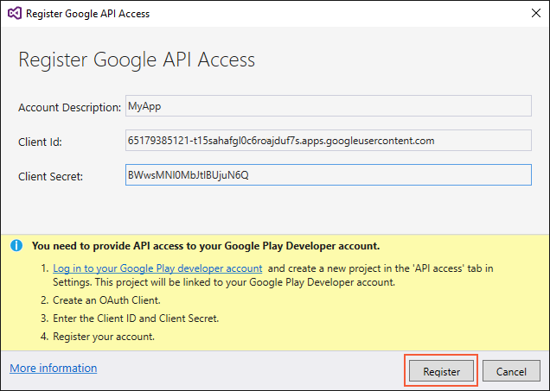

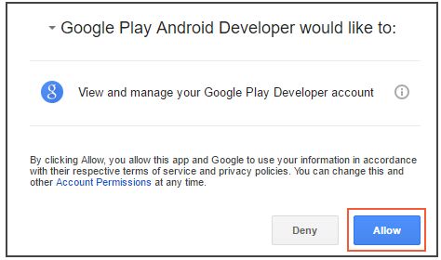

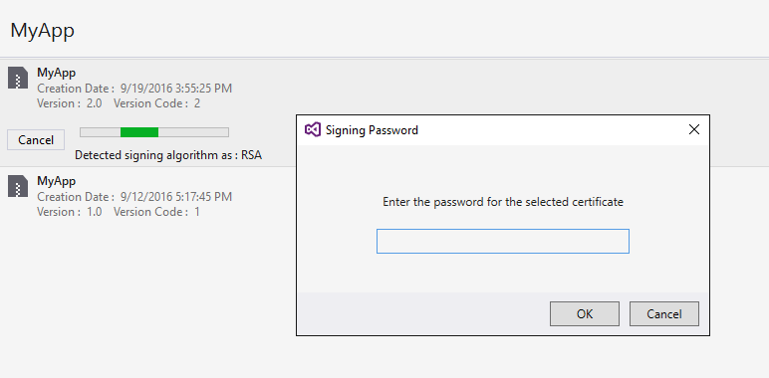

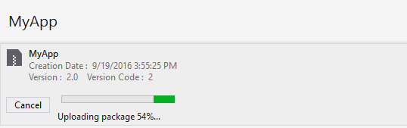

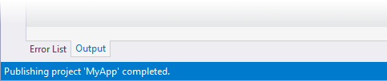

Final you are done with publishing the app